User Manual

Matthew Yun

Eagle Admin

School Administration System



Table of Contents

**1.)Onboarding Educators** 6

**1.1)Step by step procedure 🡪 Onboarding Educators** 6

**1.2)Step by step procedure 🡪 Activate your account via email** 7

**1.3)Step by step procedure 🡪 Creating a password** 7

**2)Complete your profile** 9

**2.1)Step by step guide 🡪 Navigating to your profile** 9

**2.2)Step by step guide 🡪 Updating your profile** 9

**3)Complete your school profile** 10

**3.1)Step by step guide 🡪 Navigating to your schools profile** 10

**3.2)Step by step guide 🡪 Navigating to your schools profile** 10

**3.3)Step by step guide 🡪 Editing your schools profile(Basic Info)** 10

**3.4)Step by step guide 🡪 Navigating to your school logo** 12

**3.5)Step by step guide 🡪 Uploading your school Logo** 12

**4)Managing Your Schools(Adding schools)** 14

**4.1)Step by step guide 🡪 Navigate to “My Schools”** 14

**4.2)Step by step guide 🡪 Navigate to “Create School”** 14

**4.3)Step by step guide 🡪 Creating a school** 15

**4.4)Step by step guide 🡪 Complete you school profile** 15

**5)Managing Your Schools(Switching schools)** 16

**5.1)Step by step guide 🡪 Navigate to “My Schools”** 16

**6.)Adding users to your school** 17

**6.1)Step by step guide 🡪 Navigation to your users** 17

**6.2)Step by step guide 🡪 Adding users to your school** 17

**7.)Setting up your grades in your school(Adding Grades)** 18

**7.1)Step by step guide 🡪 Navigate to your grades** 18

**7.2)Step by step guide 🡪 Adding grades to your school** 18

**8.)Setting up your grades in your school(Edit your Grades)** 19

**8.1)Step by step guide 🡪 Navigate to your grades** 19

**8.2)Step by step guide 🡪 Selecting the grade to edit** 19

**8.3)Step by step guide 🡪 Editing the grades in your school** 20

**9.)Setting up your grades in your school(Deleting your grades)** 21

**9.1)Step by step guide 🡪 Navigate to your grades** 21

**9.2)Step by step guide 🡪 Deleting your grades** 21

**10.)Setting up your homerooms in your school(Adding Homerooms)** 22

**10.1)Step by step guide 🡪 Navigate to your homerooms** 22

**10.2)Step by step guide 🡪 Creating your homerooms** 22

**11.)Setting up your grades in your school(Editing Homerooms)** 23

**11.1)Step by step guide 🡪 Navigate to your homerooms** 23

**11.2)Step by step guide 🡪 Navigate to your homerooms** 23

**11.3)Step by step guide 🡪 Navigate to your homerooms** 23

**11.4)Step by step guide 🡪 Editing your homerooms** 24

**12.)Setting up and managing your grade fees(Adding grade fees)** 25

**12.1)Step by step guide 🡪 Navigate to manage fees** 25

**12.2)Step by step guide 🡪 Navigate to manage fees** 25

**12.3)Step by step guide 🡪 Navigate to manage fees** 26

**12.4)Step by step guide 🡪 Creating your grade fee** 26

**13.)Setting up and managing your grade fees(Viewing and disabling grade fees)** 27

**13.1)Step by step guide 🡪 Navigate to manage fees** 27

**13.2)Step by step guide 🡪 Navigate to manage fees** 27

**13.3)Step by step guide 🡪 Navigate to manage fees** 27

**13.4)Step by step guide 🡪 Disabling your grade fees** 28

**14.)Setting up and managing your add-on fees(Adding Add-on Fees)** 29

**14.1)Step by step guide 🡪 Navigate to manage fees** 29

**14.2)Step by step guide 🡪 Navigate to manage add-on fees** 29

**14.3)Step by step guide 🡪 Navigating to your addon fees** 30

**14.4)Step by step guide 🡪 Navigate to manage add-on fees** 30

**15.)Setting up and managing your add-on fees(Disabling or Archiving Add-on Fees)** 31

**15.1)Step by step guide 🡪 Navigate to manage fees** 31

**15.2)Step by step guide 🡪 Navigate to manage add-on fees** 31

**15.3)Step by step guide 🡪 Navigating to your add-on fees** 32

**15.4)Step by step guide 🡪 Archiving or disabling your add-on fee** 32

**16.)Managing your students(Adding students)** 33

**16.1)Step by step guide 🡪 Navigating to the students section** 33

**16.2)Step by step guide 🡪 Navigating to the create students section** 33

**16.3)Step by step guide 🡪 Adding Students** 33

**17.)Managing your students(Viewing and Editing Students)** 35

**17.1)Step by step guide 🡪 Navigating to the students section** 35

**17.2)Step by step guide 🡪 Navigating to Browse Students** 35

**17.3)Step by step guide 🡪 Selecting the Student to view** 35

**17.4)Step by step guide 🡪 Editing Students Details** 36

**18.)Managing your parents(Adding and Linking parents[Preferred method])** 37

**18.1)Step by step guide 🡪 Navigating to the students section** 37

**18.2)Step by step guide 🡪 Navigating to Browse Students** 37

**18.3)Step by step guide 🡪 Selecting the Student to view** 37

**18.4)Step by step guide 🡪 Navigating to Adding Parents** 38

**18.5)Step by step guide 🡪 Creating and Linking the Parent** 38

**19.) Managing your parents(Removing the association of a parent from a student)** 40

**19.1)Step by step guide 🡪 Navigating to the students section** 40

**19.2)Step by step guide 🡪 Navigating to Browse Students** 40

**19.3)Step by step guide 🡪 Selecting the Student to view** 40

**19.4)Step by step guide 🡪 Navigating to Adding Parents** 41

**20A.) Managing your students(Assigning your homeroom)** 42

**20A.1)Step by step guide 🡪 Navigating to the students section** 42

**20A.2)Step by step guide 🡪 Navigating to Browse Students** 42

**20A.3)Step by step guide 🡪 Selecting the Student to view** 42

**20A.4)Step by step guide 🡪 Navigating to Assigning homerooms** 43

**20A.5)Step by step guide 🡪 Assigning homerooms** 43

**20B.) Managing your students(Mass Assigning Student to a Homeroom)** 44

**20B.1)Step by step guide 🡪 Navigating to the students section** 44

**20B.2)Step by step guide 🡪 Navigating to browse to assign homerooms** 44

**20B.3)Step by step guide 🡪 Filtering the students to assign to a homeroom** 44

**20B.4)Step by step guide 🡪 Filtering the students to assign to a homeroom** 45

**21.1)Step by step guide 🡪 Navigating to the students section** 46

**21.2)Step by step guide 🡪 Navigating to Browse Students** 46

**21.3)Step by step guide 🡪 Selecting the Student to view** 46

**21.4)Step by step guide 🡪 Navigating to creating an account** 47

**21.5)Step by step guide 🡪 Creating an account** 47

**22.) Manage your accounts(Viewing and updating your account)** 49

**22.1)Step by step guide 🡪 Navigating to the Accounts section** 49

**22.2)Step by step guide 🡪 Viewing and selecting an account** 49

**22.3)Step by step guide 🡪 Viewing and making changes to your account** 49

**23.) Manage your accounts(Making a once off transaction on the account)** 51

**23.1)Step by step guide 🡪 Navigating to the Accounts section** 51

**23.2)Step by step guide 🡪 Viewing the account to make transactions** 51

**23.3)Step by step guide 🡪 Navigating to the Accounts section** 52

**24.) Manage your accounts(Using the quick pay feature)** 53

**24.1)Step by step guide 🡪 Navigating to the Quick Pay section** 53

**24.2)Step by step guide 🡪 Navigating to the account within the Quick Pay section** 53

**24.2)Step by step guide 🡪 Creating a quick transaction** 53

**25.) Manage your accounts(Billing the whole school, grades or homerooms)** 55

**25.1)Step by step guide 🡪 Navigating to the Assisted Billing Section** 55

**25.2)Step by step guide 🡪 Starting with the assisted billing process** 55

**25.3)Step by step guide 🡪 Billing selection and submission** 56

**25.4)Step by step guide 🡪 Billing Results** 56

**26.) Viewing your billing results** 57

**26.1)Step by step guide 🡪 Navigating to the Assisted Billing Results Section** 57

**26.2)Step by step guide 🡪 Selecting the period in which the Assisted Billing had taken place** 57

**27.) Manage your accounts(Viewing transactions within an account)** 58

**27.1)Step by step guide 🡪 Navigating to the Accounts section** 58

**27.2)Step by step guide 🡪 Selecting the account to view** 58

**27.3)Step by step guide 🡪 Selecting the account to view** 58

**28.) Manage your accounts(Viewing statements of a single account)** 60

**28.1)Step by step guide 🡪 Navigating to the Accounts section** 60

**28.2)Step by step guide 🡪 Selecting the account to view** 60

**28.3)Step by step guide 🡪 Downloading the PDF Statement of an account.** 61

**29.) Manage your accounts(Downloading all accounts in a single PDF file)** 62

**29.1)Step by step guide 🡪 Navigating to the Accounts section** 62

**29.2)Step by step guide 🡪 Download all accounts in a single pdf** 62

**30.) Manage your accounts(Setting up red lines on an account)** 63

**30.1)Step by step guide 🡪 Navigating to the Accounts section** 63

**30.2)Step by step guide 🡪 Selecting the account to view** 63

**30.3)Step by step guide 🡪 Red Lining an account** 63

**30.4)Step by step guide 🡪 Verifying to Redline the account** 64

**31.) Manage your accounts(checking if a parent is RedLined)** 65

**31.1)Step by step guide 🡪 Lookup Red Lines section** 65

**31.2)Step by step guide 🡪 Using the Lookup RedLines** 65

**31.3)Step by step guide 🡪 RedLine Results** 65

**32.) Viewing Reports** 67

**32.1)Step by step guide 🡪 Navigating to reports** 68

**33.) Viewing the schools statement of account with Eagle Admin** 69

**33.1)Step by step guide 🡪 Navigating to my account with Eagle Admin** 69

**33.2)Step by step guide 🡪 Downloading my Statement with Eagle Admin** 69

**34.) Accessing the help feature** 70

**34.1)Step by step guide 🡪 Navigating to the help section** 70

**1.)Onboarding Educators**

Educators can onboard onto the system with the assistance of the Eagle admin team. Only users with the intent of using Eagle Admin for their school administrative purposes will be granted access to Eagle Admin. By doing this, this will improve the security and integrity of the data that is stored within the system.

**1.1)Step by step procedure 🡪 Onboarding Educators**

1) To onboard onto Eagle Admin, please provide your following details below:

🡪First Name

🡪Last Name

🡪Email Address

🡪School Name

Email these details to [Team@eagleadmin.co.za](mailto:Team@eagleadmin.co.za).

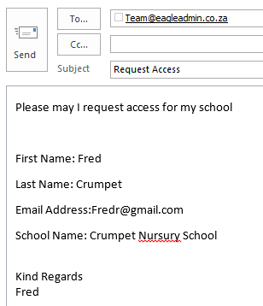

**1.2)Step by step procedure 🡪 Activate your account via email**

Once an Eagle Admin team member has accepted your details, you will receive an activation email as seen below:

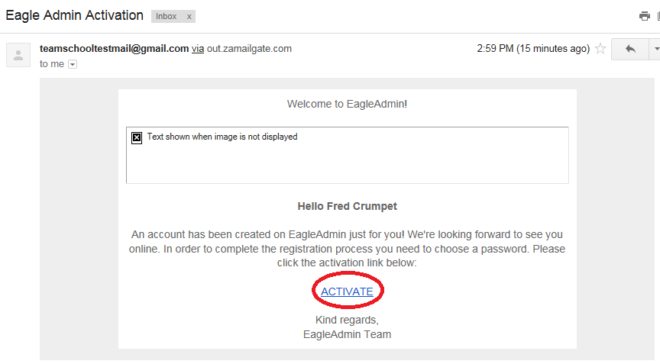

Please click on the “Activate” button shown above to activate your account.

**1.3)Step by step procedure 🡪 Creating a password**

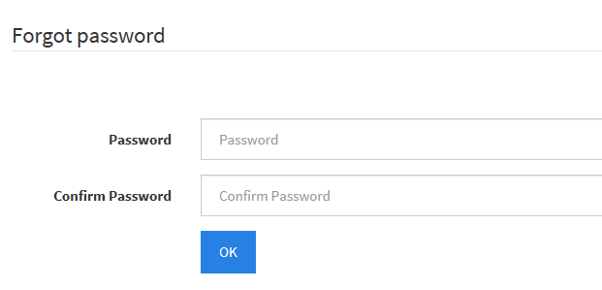Once you have clicked on the activation link, you will be prompted by a screen in which you will have to enter your password as displayed below:

* Click on the “OK” button to proceed. Your account is now active.

**2)Complete your profile**

Your personal profile should be completed for auditing purposes and so that functionality that requires additional information will be available when needed.  
Your password and email address can also be changed under your profile settings.

**2.1)Step by step guide 🡪 Navigating to your profile**

Please navigate to your profile my clicking on “My Eagle”, then navigating to “My Profile” as displayed below:  
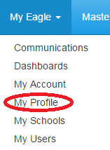

**2.2)Step by step guide 🡪 Updating your profile**

All your profile details should be updated such as your Name, Surname, Cellphone Number and Telephone number.

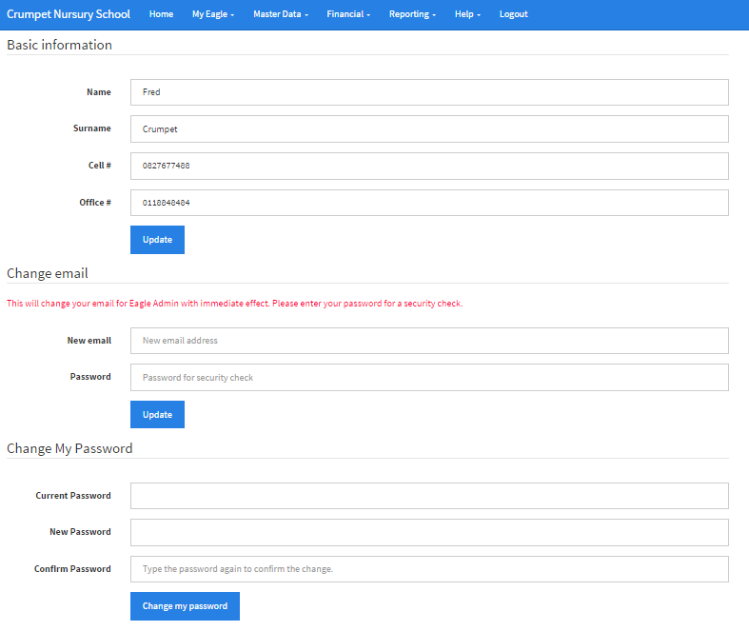

If you have changed your email address, you may change your email address through viewing your profile as well. Changing your password can also be done through your profile as seen above.

**3)Complete your school profile**

Your school details should be updated as this is very vital when it comes to printing out your statements and handing them to clients. The statement will include things like the schools banking details, Address, Telephone number, notes that will be printed at the bottom of the statement etc.

## **3.1)Step by step guide 🡪 Navigating to your schools profile**

Please navigate to your schools profile my clicking on “My Eagle”, then navigating to “My Schools” as displayed below:

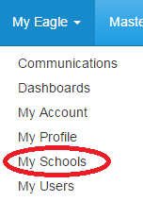

**3.2)Step by step guide 🡪 Navigating to your schools profile**

Navigate to the “Edit school details” section as displayed below:

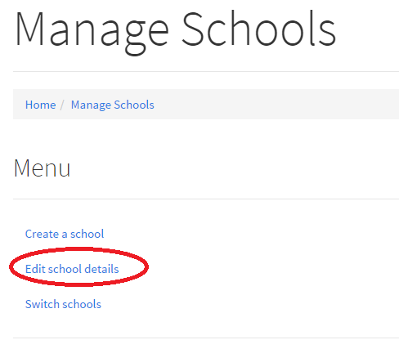

**3.3)Step by step guide 🡪 Editing your schools profile(Basic Info)**

You will be presented with the fields below that should be filled in as it will be presented to clients on their monthly statements. The display name, Legal Entity Name, Address Line 1, Address Line 2(if applicable), Landline number and Fax number(If applicable).  
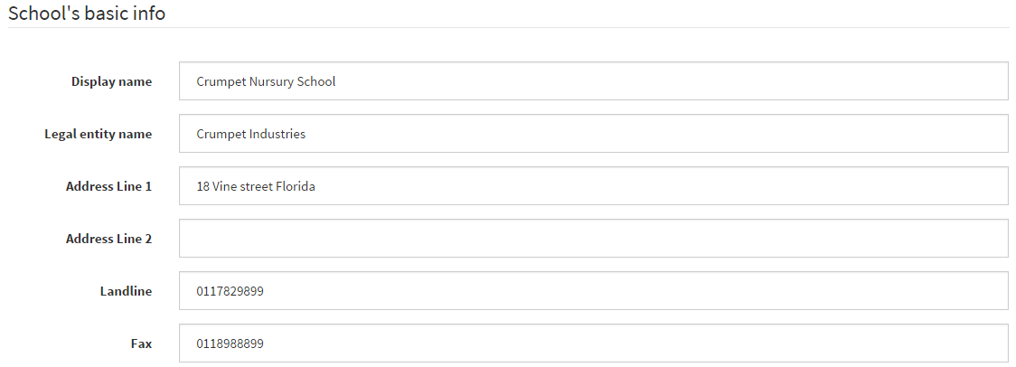

The billing email displayed below is the email address that is used for your schools business. Emails will not be sent out using the Eagle Admin email address but the email addressed used by the schools billing department.  


Ensure that your banking details are filled out, as this will be printed onto the clients monthly statements  
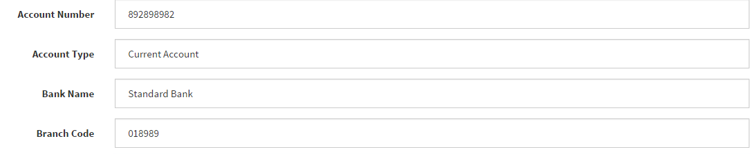

The Disclaimer will be printed at the bottom section of the statement and can be used to notify clients, the penalties that are involved with late payment of fees.  
Ensure that the “Active” status is enabled in order for the school to be enabled and functioning.  
Once the basic school details have been filled out, click on the “Update” button to save the changes that has been made.

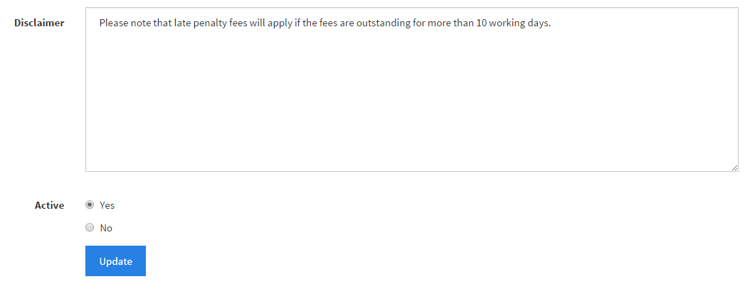

**3.4)Step by step guide 🡪 Navigating to your school logo**

Please ensure that you upload your school logo as your school Logo will appear on your school statements that will be sent out to clients.  
Navigate to the “School Logo” tab displayed below:  
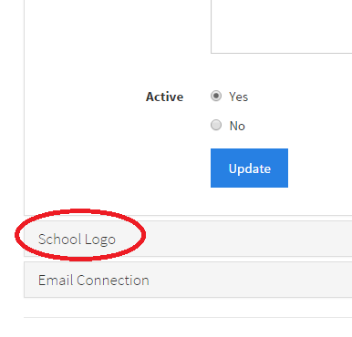

**3.5)Step by step guide 🡪 Uploading your school Logo**

Select the “Choose File” button to upload your school logo, once a file has been selected, click on the “Upload” button displayed below to upload your school logo.  
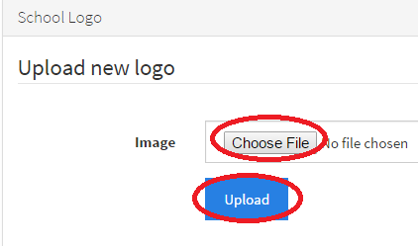

**3.6)Step by step guide 🡪 Navigating to your email settings**

This next step is a very important step, in order for your statements to be emailed to your clients. You will need to ask your administrators who are in charge of your emails for these settings. There is a need for this step as Eagle Admin will not be sending out the statements to parents as statements need to come from their appropriate location eg) [accounts@aurora.co.za](mailto:accounts@aurora.co.za). Email communication and sending out of statements from Eagle Admin will not work without these settings.  
Please navigate to the “Email Connection” tab just below the “School Logo” tab as seen in the image below.

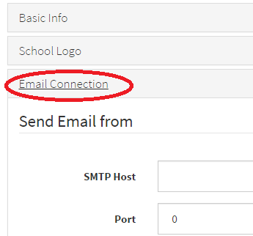

**3.7)Step by step guide 🡪 Configuring your email settings**

Please enter the fields associated with your email account. Fill in the SMTP host, port, Username, Password and if your connecting via TLS or SSL. Once your email settings have been verified, click on the “Test” button shown below to test the email settings to ensure that the email settings are correct. Once you are happy with the email settings, click on the “Save” button displayed below.  
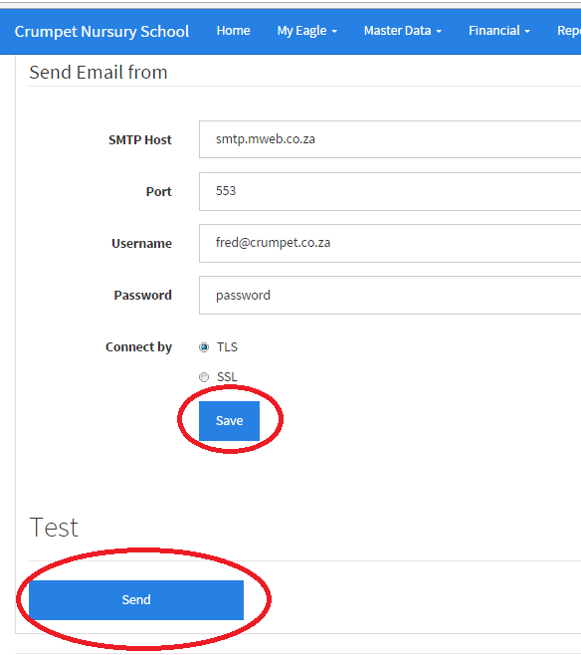

# **4)Managing Your Schools(Adding schools)**

You can manage and add multiple schools under your single user account. For example if you would like to separate your primary school from your high school for reporting reasons, you may manage them under this function.

**4.1)Step by step guide 🡪 Navigate to “My Schools”**

Please navigate to “My Schools” under the “My Eagle” menu as displayed below.

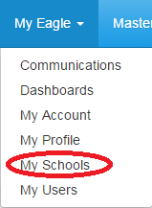

**4.2)Step by step guide 🡪 Navigate to “Create School”**

You will be presented with the screen below. To create a new school, navigate   
to “Create a new School”, shown below:

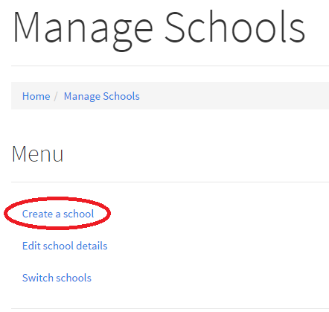

**4.3)Step by step guide 🡪 Creating a school**

Please fill in your Schools Name and your Legal Entity Name of your school. Once complete, click on the “Create” button as seen below:  
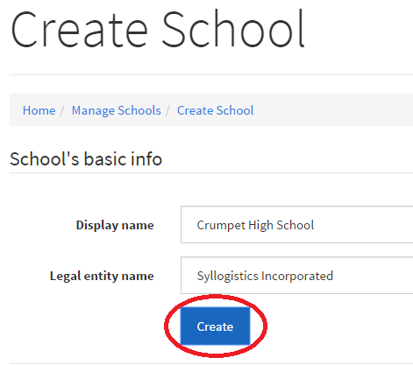

**4.4)Step by step guide 🡪 Complete you school profile**

You will now be re-directed to “3.Complete your school profileStep_by_step)” to fill in your schools details. Please note that to know that you are interacting with the correct school, the school name will appear on the top left hand side of the screen as displayed below.

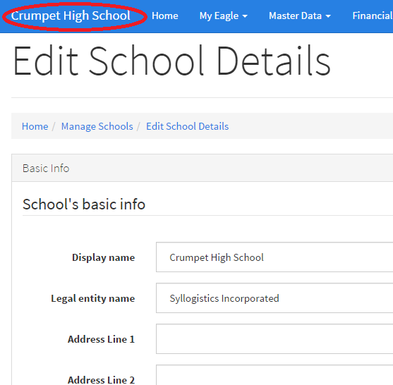

# **5)Managing Your Schools(Switching schools)**

Once you have completed adding your schools in step 4, switching between the schools can be done in a few easy steps.

**5.1)Step by step guide 🡪 Navigate to “My Schools”**

Please navigate to “My Schools” under the “My Eagle” menu as displayed below.

**5.2)Step by step guide 🡪 Navigate to “Switch Schools ”**

Navigate to the “Switch Schools” function as displayed below.

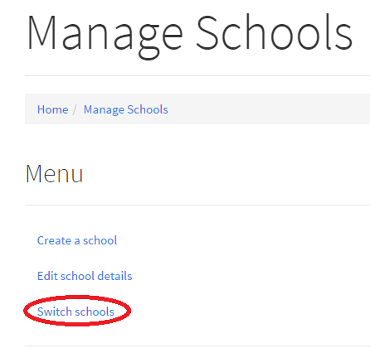

**5.3)Step by step guide 🡪 Switching Schools**

You will be presented with the following screen below. Please click on a school In which you would like to switch to. The school will be highlighted that you are currently on. The school that you are also currently interacting as will also be displayed on the top left hand corner of the screen as displayed below:

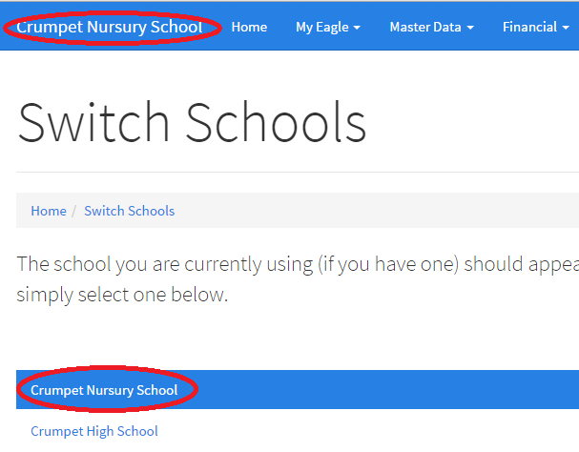

# **6.)Adding users to your school**

Adding users to your school adds accountability and a tracking of which you can identify the transactions that each user has done. To add users, please follow the steps as displayed below.

## **6.1)Step by step guide 🡪 Navigation to your users**

Please navigate to “My users” under the “My Eagle” tab as displayed below.

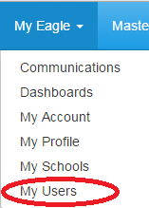

**6.2)Step by step guide 🡪 Adding users to your school**

You will be displayed with the page below with the accounts that are active for the school. If you would like to add additional users to the school, please add the additional email addresses displayed below with the role you would like to associate with the new account. Once the new account details have been confirmed, click on the “Create” button as seen below. This will send an email to their email address which the user will have to carry on from step 1.2 within this document.

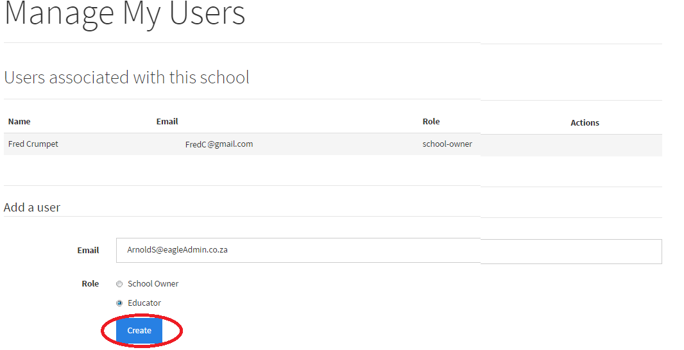

# **7.)Setting up your grades in your school(Adding Grades)**

Setting up your grades is important, so that grade fees and students can be associated to your grade.

**7.1)Step by step guide 🡪 Navigate to your grades**

Please navigate to your grades via the “Master Data” tab, then to “Grades”.

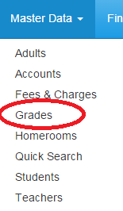

**7.2)Step by step guide 🡪 Adding grades to your school**

Please fill in your grades going from the highest grade going to the lowest grade as you will need to fill in the:  
**Grade Name** = Name of grade

**Weight** = the order in which the grades will be sorted. Eg. If you would like grade 1 to be on the top of the list, grade 1 will have a weight of 1, grade 2 with a weight of 2 etc.  
**Next Grade** = select the grade which is after the one that is being created. Please ensure that the next grade is selected as the following year, students will be moved to the next grade automatically.

The reason why the grades must be created from the highest to the lowest is so that if you create grade 12 then grade 11, in grade 11 you can select that grade 12 is the next grade.

Click on the “Create” button once your happy filling in the grade details, this must be done for each grade.  
Please see below for an example.

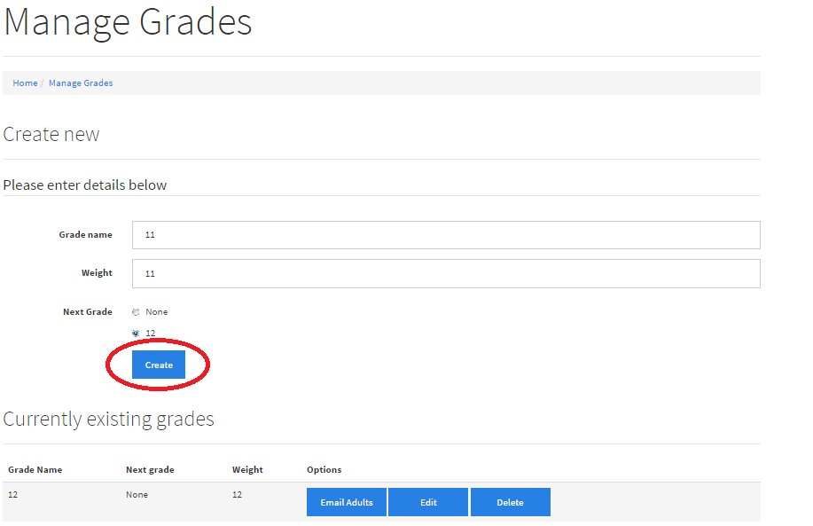

# **8.)Setting up your grades in your school(Edit your Grades)**

Grades can be edited if a mistake has been made or you would like to restructure your grades.

## **8.1)Step by step guide 🡪 Navigate to your grades**

Please navigate to your grades via the “Master Data” tab, then to “Grades”.



## **8.2)Step by step guide 🡪 Selecting the grade to edit**

Your grades will be displayed under the “Current existing grades” as seen below. Click on the “Edit” button associated to the grade in which you would like to edit.  
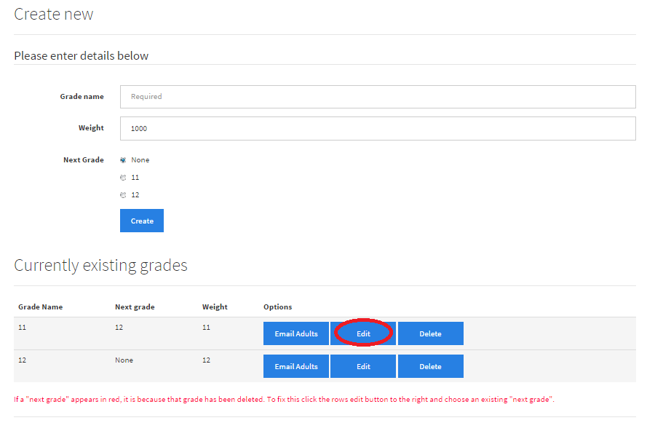

**8.3)Step by step guide 🡪 Editing the grades in your school**

The screen will be displayed below where changes you would like to be made to the grade can be done.

Once the appropriate changed has been made, click on the “Update” button as seen below:  
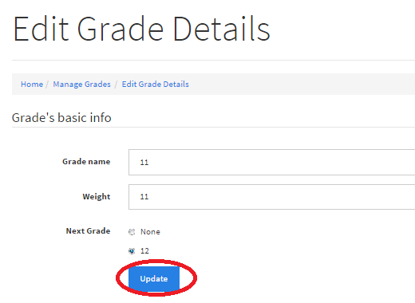

# **9.)Setting up your grades in your school(Deleting your grades)**

If too many grades have been created or if there was a mistake that has been made, there is a delete function to delete grades.

## **9.1)Step by step guide 🡪 Navigate to your grades**

Please navigate to your grades via the “Master Data” tab, then to “Grades”.

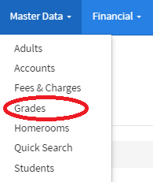

**9.2)Step by step guide 🡪 Deleting your grades**

You will be presented with the image below, please select the appropriate grade you would like to delete and click on the “Delete” button as displayed below.

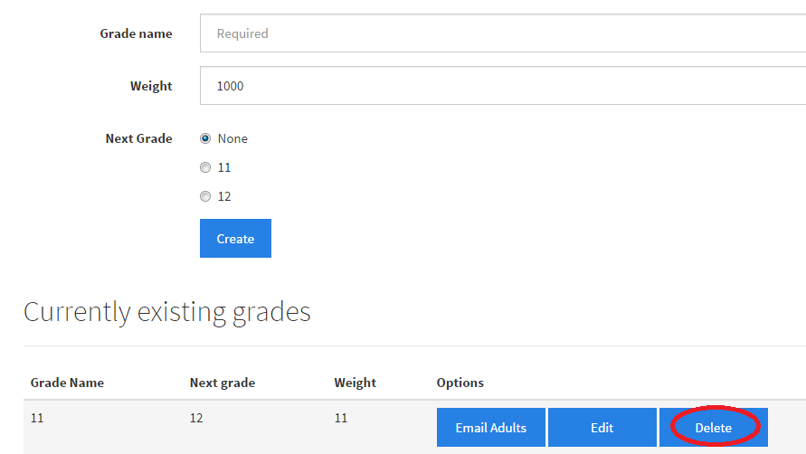

A message will then be displayed, confirming the deletion of the grade/

# **10.)Setting up your homerooms in your school(Adding Homerooms)**

Homerooms can be added and linked to grades, students will then be placed in their appropriate homerooms.

## **10.1)Step by step guide 🡪 Navigate to your homerooms**

Please navigate to your grades via the “Master Data” tab, then to “Homerooms”.

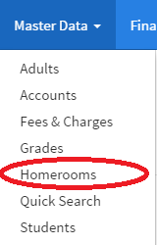

**10.2)Step by step guide 🡪 Creating your homerooms**

You will then be presented with the create Homeroom page to create your Homroom. Please enter the homeroom name and if there is an alternative homeroom name, there is an option to fill that in.  
Please assign the homeroom to the appropriate grade seen below.  
If you would like to view the homeroom just after you have created it, click on the “View the homeroom (more options)” .If you would like to proceed to creating another homeroom after creating the current one, click on the “Create another homeroom” option.  
Once you are happy with the details of the homeroom you would like to create, click on the “Create” button.

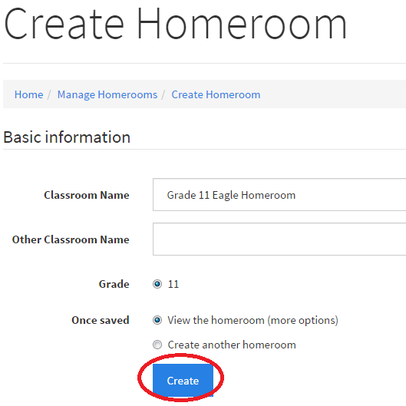

# **11.)Setting up your grades in your school(Editing Homerooms)**

You may edit homerooms due to a homeroom name change through this function.

## **11.1)Step by step guide 🡪 Navigate to your homerooms**

Please navigate to your grades via the “Master Data” tab, then to “Homerooms”.



**11.2)Step by step guide 🡪 Navigate to your homerooms**

Navigate to the “Browse Homeroom” option as seen below.  
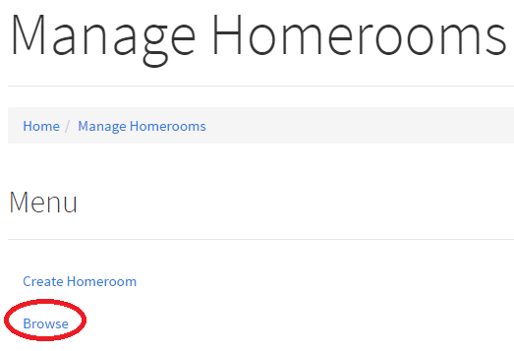

**11.3)Step by step guide 🡪 Navigate to your homerooms**

Navigate to the homeroom you would like to edit by clicking on the “View” button associated to the homeroom you would like to edit as shown below.

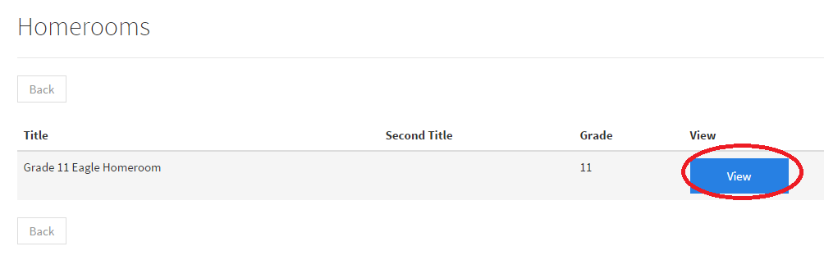

**11.4)Step by step guide 🡪 Editing your homerooms**

The details of the homeroom that you have selected will be shown in this next step, once changes have been made to the homeroom, click on the “Update” button to update the details of the homeroom as shown below.

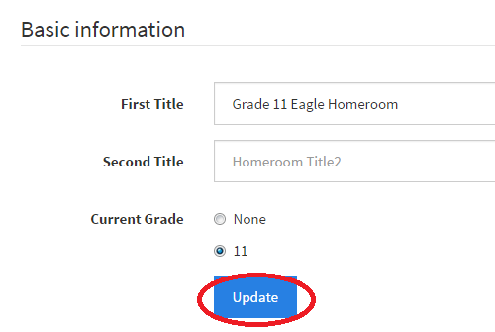

Please also note that you will also be able to see which students are associated with the homeroom by scrolling further down the page.

# **12.)Setting up and managing your grade fees(Adding grade fees)**

Your grades and homerooms will now be fully setup and functional, you will now have to setup your grade fees that will be applied to each grade.

## **12.1)Step by step guide 🡪 Navigate to manage fees**

Please navigate to the “Master Data” tab, then to “Fees & Charges” as displayed below.

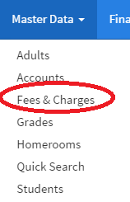

## **12.2)Step by step guide 🡪 Navigate to manage fees**

You will be presented with the screen below. Please navigate to “Manage Grade Fees” as shown below.

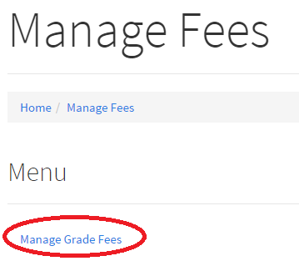

## **12.3)Step by step guide 🡪 Navigate to manage fees**

You will be presented with the screen below. Please click on the “Create grade fee” button to create a new grade fee.

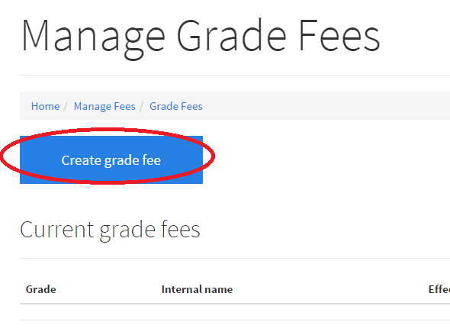

## **12.4)Step by step guide 🡪 Creating your grade fee**

Please fill in the Internal Name(A useful name for internal purposes eg) Grade 11 School fees), Bill Line(The description that will be displayed on the statement), Amount( The amount you would like to charge the parent per month), Grade( Select the grade to apply these fees to). Once created, click on the “Create” button as shown below

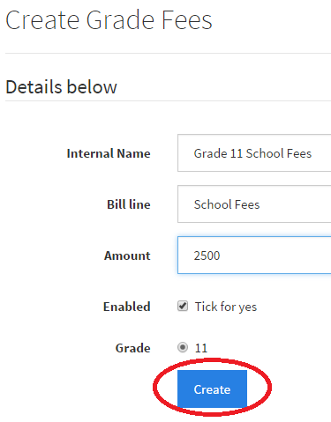

# **13.)Setting up and managing your grade fees(Viewing and disabling grade fees)**

If you would like to view or disabled grade fees due to a specific grade fee being no longer in use, please follow the guide below

## **13.1)Step by step guide 🡪 Navigate to manage fees**

Please navigate to the “Master Data” tab, then to “Fees & Charges” as displayed below.



## **13.2)Step by step guide 🡪 Navigate to manage fees**

You will be presented with the screen below. Please navigate to “Manage Grade Fees” as shown below.



## **13.3)Step by step guide 🡪 Navigate to manage fees**

You current grade fees will be shown under the “Current Grade Fees” section. Please click on the “View” button on the grade fees you would like to view.

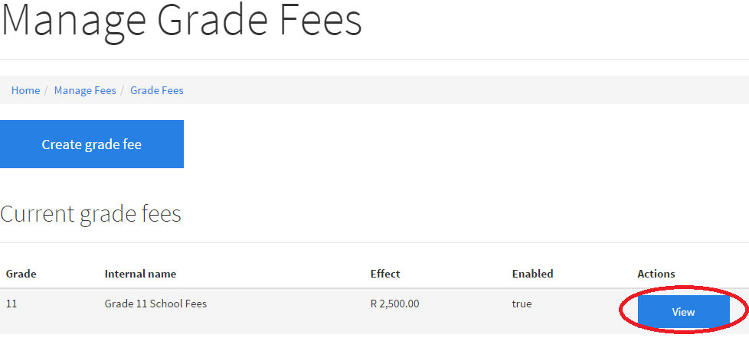

## **13.4)Step by step guide 🡪 Disabling your grade fees**

To disable your grade fees, please take out the tick for the enabled option as shown below. Please click on the “Update” button, once the details are confirmed for the current grade fees.

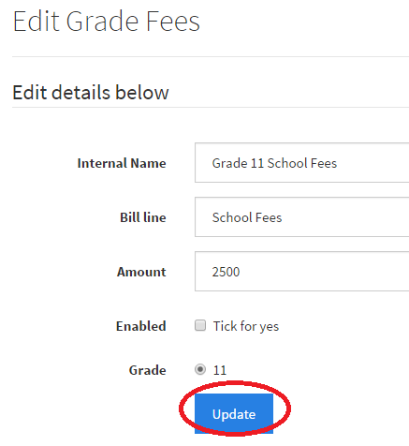

# **14.)Setting up and managing your add-on fees(Adding Add-on Fees)**

Your add-on fees will be additional fees apart from school fees. These fees can be things like aftercare fees, once of photo fees, camp fees etc. If you would like to only allow the add-on fee’s to be active for 1 month, it is your responsibility to either archive or delete these fees before an Assisted Billing cycle is created.

## **14.1)Step by step guide 🡪 Navigate to manage fees**

Please navigate to the “Master Data” tab, then to “Fees & Charges” as displayed below.

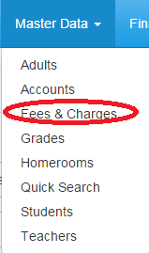

## **14.2)Step by step guide 🡪 Navigate to manage add-on fees**

Please navigate to the “Master Data” tab, then to “Manage Addon Fees” as displayed below.

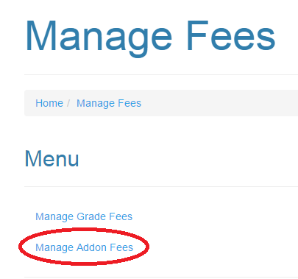

## **14.3)Step by step guide 🡪 Navigating to your addon fees**

This page will display your current add-on fees, to create a new add-on fee, click on the “Create addon fee” button as shown below.

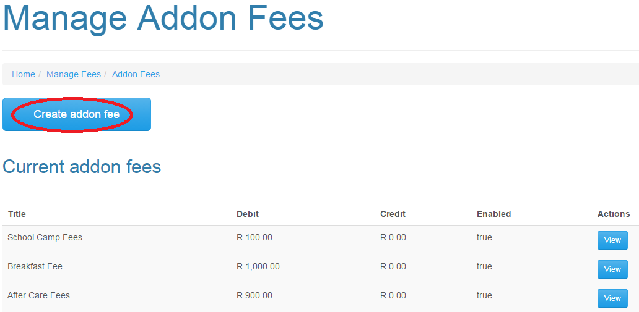

## **14.4)Step by step guide 🡪 Navigate to manage add-on fees**

Please enter the Title of the Fee and specify if this should be a debit or credit fee as shown below. Once created, click on the “Create” button as shown below.

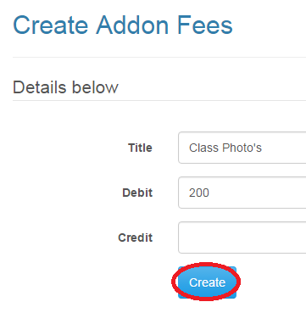

# **15.)Setting up and managing your add-on fees(Assigning students to your add-on fees/ Removing add-on fees)**

The next step is to assign students to the add-on fees that have been created. Add-on fees will only apply to select students as only a selected few will require an add-on fee. The removing of add-on fees for a student will be shown in this section as well.

## **15.1)Step by step guide 🡪 Navigate to manage students**

Please navigate to the “Master Data” tab, then to “Manage Students” as displayed below.

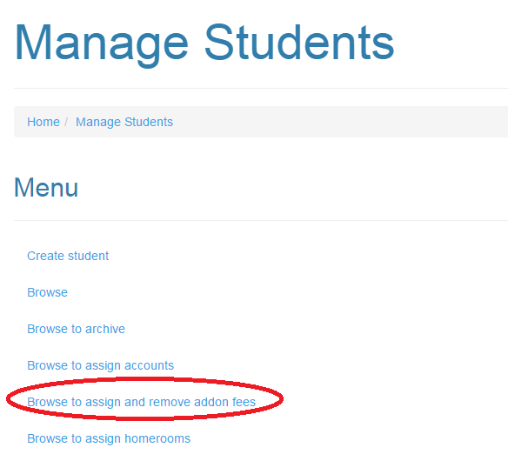

## **15.2)Step by step guide 🡪 Selecting the students to assign add-on fees**

You will be presented with the screen below. You may filter students via the filter tabs to find the specific students you would like to assign to the same homeroom. You may filter students via the Gender, Grade and Homeroom tab to display only certain students. Once you have the students filtered, you must click on the “Assign” button associated with the student as shown below.

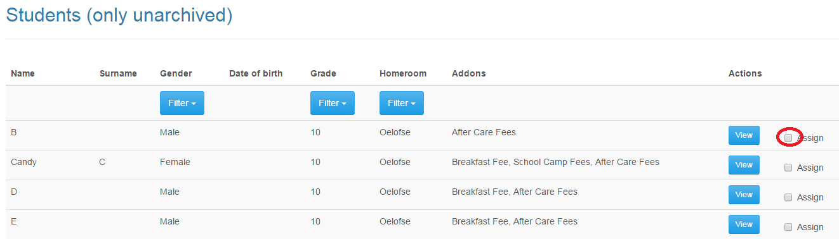

## **15.3)Step by step guide 🡪 Selecting your Add-on fees to assign to the students selected/ Removing add-on fees**

Once you have selected the students you would like to transact with, select the add-on to add, otherwise to remove a certain add-on fee, select the remove feature. If you would like to remove all add-on’s related to a student, you may select the “Remove All” option as displayed below. Once your selection has been may, you may proceed with the action and click on the “Assign” button as shown below.

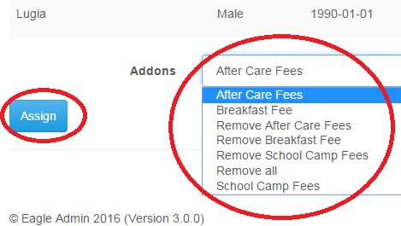

# **16.)Setting up and managing your add-on fees(Disabling or Archiving Add-on Fees)**

This process will show you how to archive or delete Add-on fees. If you would like to remove the auto billing for a specific add-on fee, please make sure you either delete or archive these add-on fees. Archiving add-on fees will allow the user to activate the add-on fee at a later stage if it’s not needed throughout the whole year. Deleting an add-on will permanently delete the add-on. Delete an Add-on if you will never use a specific add-on fee again.

## **16.1)Step by step guide 🡪 Navigate to manage fees**

Please navigate to the “Master Data” tab, then to “Fees & Charges” as displayed below.



## **16.2)Step by step guide 🡪 Navigate to manage add-on fees**

Please navigate to the “Master Data” tab, then to “Manage Add-on Fees” as displayed below.



## **16.3)Step by step guide 🡪 Navigating to your add-on fees**

This page will display your current add-on fees, click on the “view” button associated with the add-on fee you would like to archive or delete.

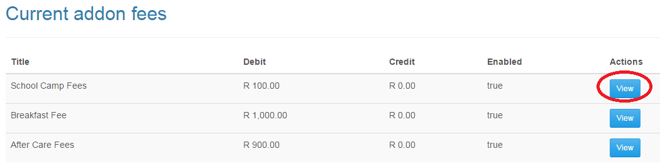

## **16.4)Step by step guide 🡪 Archiving or disabling your add-on fee**

Click on either the “Deleted” or “Archived” checkbox to either delete or archive a fee that will not be used. Once completed, click on the “Update” button to save your changes.

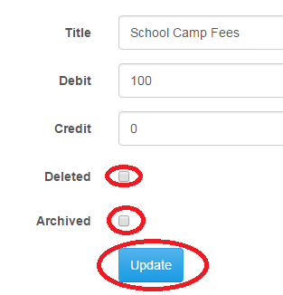

# **17.)Managing your students(Adding students)**

Adding students can be done via the following steps below:

## **17.1)Step by step guide 🡪 Navigating to the students section**

Please navigate to students under the “Master Data” menu, then to “Students”, as displayed below:

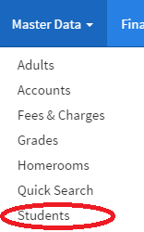

## **17.2)Step by step guide 🡪 Navigating to the create students section**

Navigate to the “Create student” link shown below.

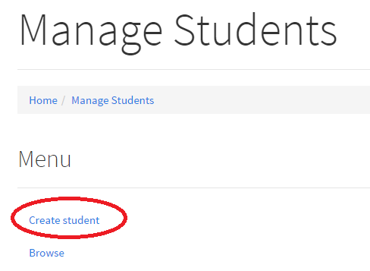

## **17.3)Step by step guide 🡪 Adding Students**

Please enter all the students details which will be displayed. Once all details have been inputted and verified you may proceed to either viewing the student after its been created, by clicking on the “View the student” option. If you would like to create another student straight after, click on the “Create another student” option. Once completed, click on the “Create” button as shown below.

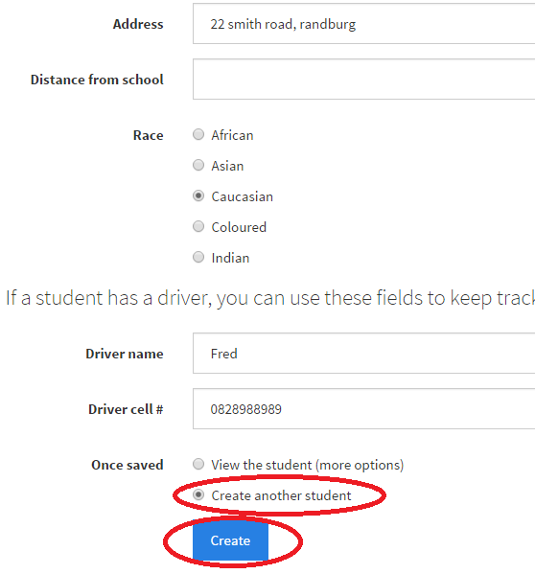

# **18.)Managing your students(Archiving students)**

Archiving students should be done if a student has left your current school. The reason to archive a student is so that the auto billing will not bill this student as well as if the student does intent to join back into the school in the future, the student does not have to be created again.

## **18.1)Step by step guide 🡪 Navigating to the students section**

Please navigate to students under the “Master Data” menu, then to “Students”, as displayed below:

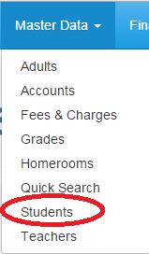

## **18.2)Step by step guide 🡪 Navigating to the browse to archive section**

Please click on the “Browse to archive” button as shown below to initiate the process to archive students.

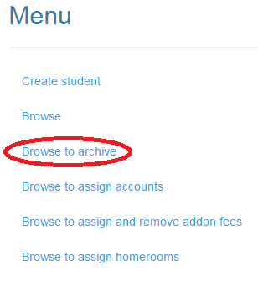

## **18.3)Step by step guide 🡪 Filtering students to archive**

You will be presented with the screen below. You may filter students via the filter tabs to find the specific students you would like to assign to the same homeroom. You may filter students via the Gender, Grade and Homeroom tab to display only certain students. Once you have the students filtered, you must click on the “Archive” button associated with the student as shown below.

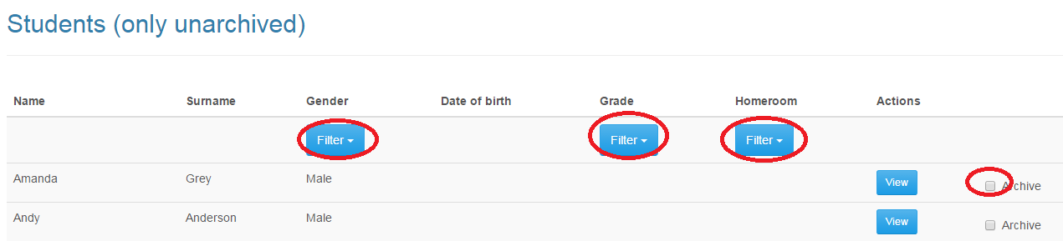

## **18.4)Step by step guide 🡪 Archiving your selected students**

Once you have selected the students you would like to transact with, select the students to archive. If you would like to remove all add-on’s related to a student, you may select the “Remove All” option as displayed below. Once your selection has been may, you may proceed with the action and click on the “Assign” button as shown below.

# **19.)Managing your students(Viewing and Editing Students)**

To view and delete students, please follow the steps shown below.

## **19.1)Step by step guide 🡪 Navigating to the students section**

Please navigate to students under the “Master Data” menu, then to “Students”, as displayed below:



## **19.2)Step by step guide 🡪 Navigating to Browse Students**

Navigate to the “Browse” link shown below.

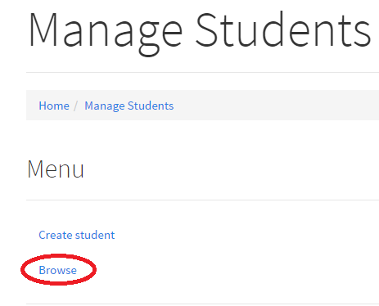

## **19.3)Step by step guide 🡪 Selecting the Student to view**

Click on the “View” button as shown below on the student’s details on which requires editing.

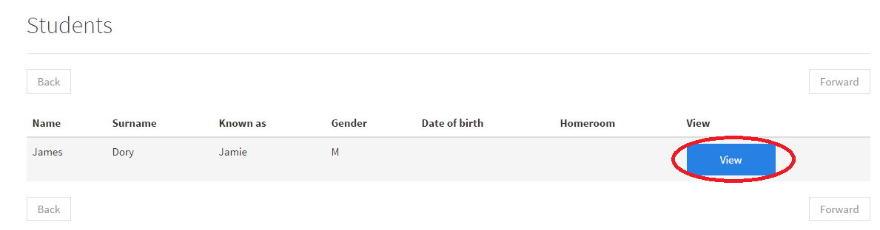

## **19.4)Step by step guide 🡪 Editing Students Details**

Click on the “Basic Info” tab as shown below to view the students details.

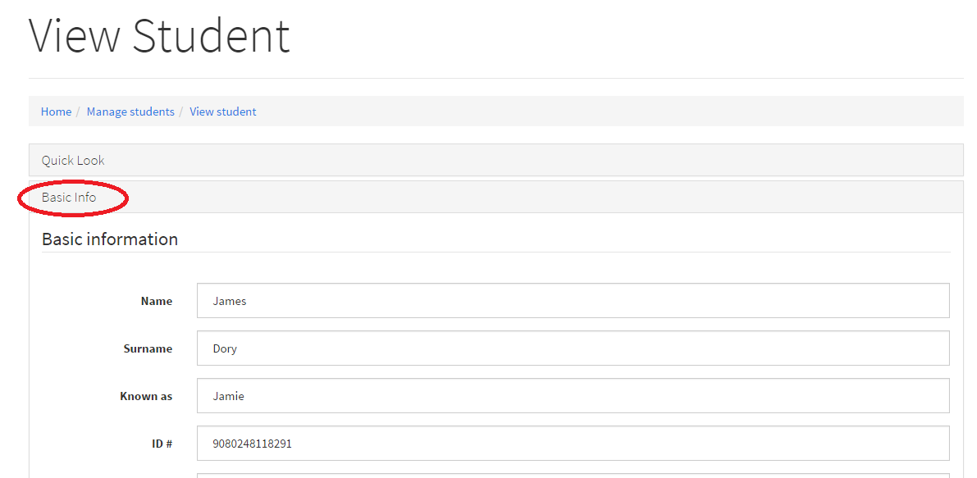

Once the changes are made, click on the “Update” button shown below.

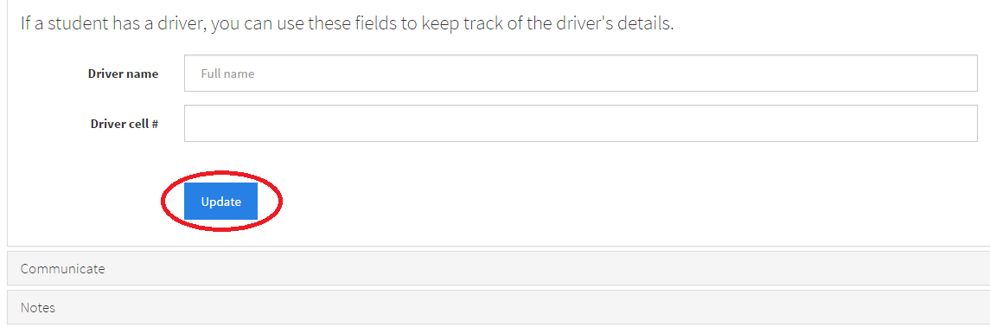

# **20.)Managing your parents(Adding and Linking parents[Preferred method])**

There is different ways to add parents onto the system, our most preferred way of adding a parents is through creating it through the child’s profile. This is so that linking and the creating of a parents can be done at the same time.   
Alternatively you can add parents under the “Master Data” tab, then click on “Adults”.

## **20.1)Step by step guide 🡪 Navigating to the students section**

Please navigate to students under the “Master Data” menu, then to “Students”, as displayed below:



## **20.2)Step by step guide 🡪 Navigating to Browse Students**

Navigate to the “Browse” link shown below.



## **20.3)Step by step guide 🡪 Selecting the Student to view**

Click on the “View” button as shown below on the student in which you would like to link and add a parent to.



## **20.4)Step by step guide 🡪 Navigating to Adding Parents**

Click on the “Links” button as shown below to expand the “links” section and under the “Adults” section, click on the “Create a new adult” button as shown below. If already have created adult, you can click on the “Assign existing adult” button to link an existing adult to the child.

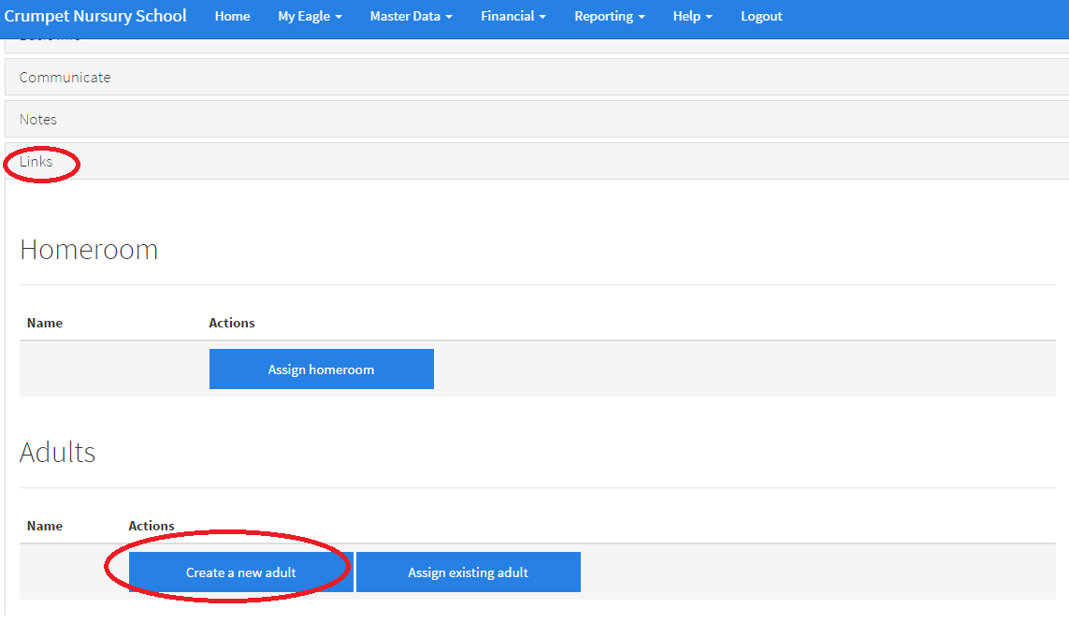

## **20.5)Step by step guide 🡪 Creating and Linking the Parent**

You will be presented with the screen below of the Adult creation, once all the details of the adult is filled out, click on the “Create” button as shown below.

Please ensure that the email address of the parent is filled out so that statements are sent to their address.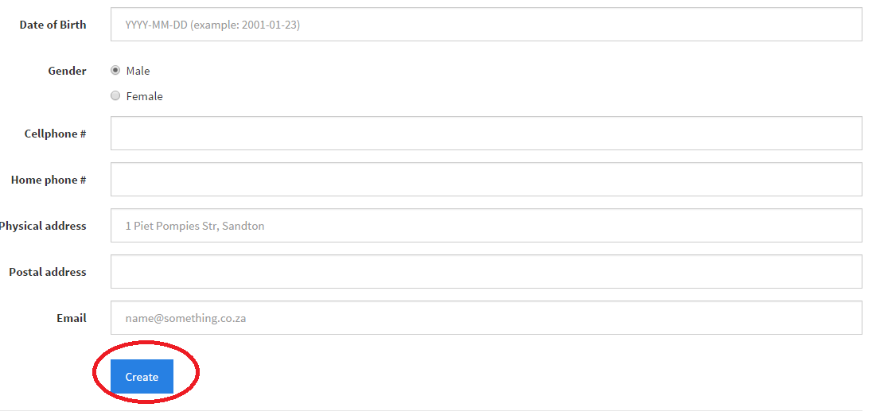

To add another parent, follow step 16.4

# **21.) Managing your parents(Removing the association of a parent from a student)**

If a mistake has been made and you would like to unlink the parent from a student, follow the steps below.

## **21.1)Step by step guide 🡪 Navigating to the students section**

Please navigate to students under the “Master Data” menu, then to “Students”, as displayed below:



## **21.2)Step by step guide 🡪 Navigating to Browse Students**

Navigate to the “Browse” link shown below.



## **21.3)Step by step guide 🡪 Selecting the Student to view**

Click on the “View” button as shown below on the student in which you would like to link and add a parent to.



## **21.4)Step by step guide 🡪 Navigating to Adding Parents**

Click on the “Links” button as shown below to expand the “links” section and under the “Adults” section, click on the “Remove” button as shown below.

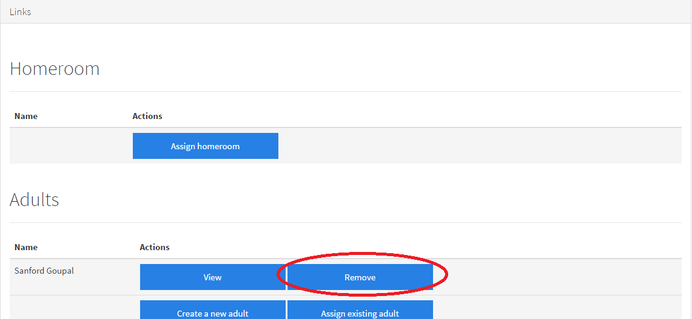

# **22A.) Managing your students(Assigning your homeroom)**

Once you have created your student, you may give them their designated homeroom.  
If you would like to look at assigning a mass amount of students to certain homeroom, please review section 18B.

## **22A.1)Step by step guide 🡪 Navigating to the students section**

Please navigate to students under the “Master Data” menu, then to “Students”, as displayed below:



## **22A.2)Step by step guide 🡪 Navigating to Browse Students**

Navigate to the “Browse” link shown below.



## **22A.3)Step by step guide 🡪 Selecting the Student to view**

Click on the “View” button as shown below on the student in which you would like to link and add a parent to.



## **22A.4)Step by step guide 🡪 Navigating to Assigning homerooms**

Click on the “Links” button as shown below to expand the “links” section and under the “Homerooms” section, click on the “Assign Homeroom” button as shown below.

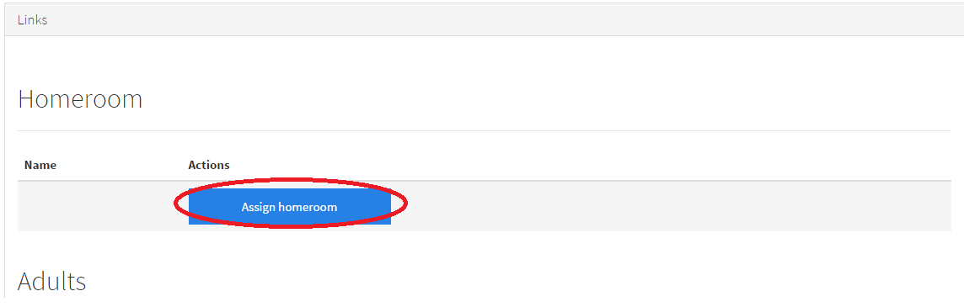

## **22A.5)Step by step guide 🡪 Assigning homerooms**

You may either search for the homeroom to assign the student to, or you can choose one of the homerooms which will be listed at the bottom of the page. Click on the “OK”

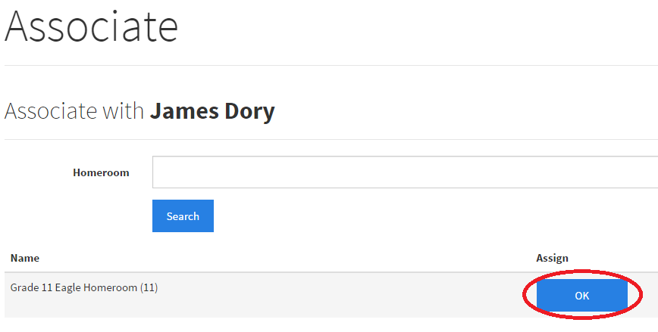

# **22B.) Managing your students(Mass Assigning Student to a Homeroom)**

This feature is very useful when it comes to assigning multiple students to a homeroom, this feature will mostly be used to move students from one homeroom to another at the end of the year once they have passed their current grade.

## **22B.1)Step by step guide 🡪 Navigating to the students section**

Please navigate to students under the “Master Data” menu, then to “Students”, as displayed below:

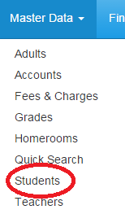

## **22B.2)Step by step guide 🡪 Navigating to browse to assign homerooms**

Please navigate to students under the “Master Data” menu, then to “Browse to assign homerooms”, as displayed below:

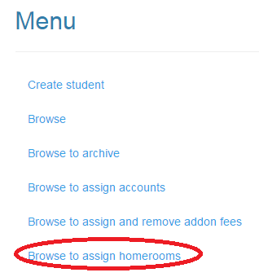

## **22B.3)Step by step guide 🡪 Filtering the students to assign to a homeroom**

In order to assign students to the homeroom, using a filter can be very useful to assigning multiple students to a homeroom. You have access to these view filters as shown below. You may filter by, Grade, Homerooms and Gender.

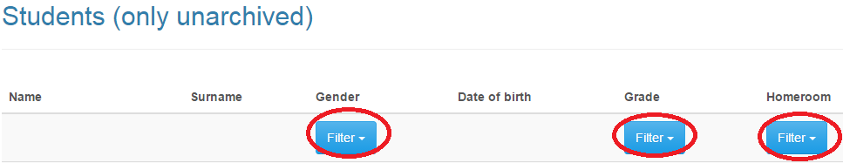

## **22B.4)Step by step guide 🡪 Filtering the students to assign to a homeroom**

Select the students in which you would like to assign to the homeroom as shown below by clicking on the “Assign” checkbox as shown below. Select to which homeroom you would like to assign these students. Once completed click on the “Assign” button to assign these students.

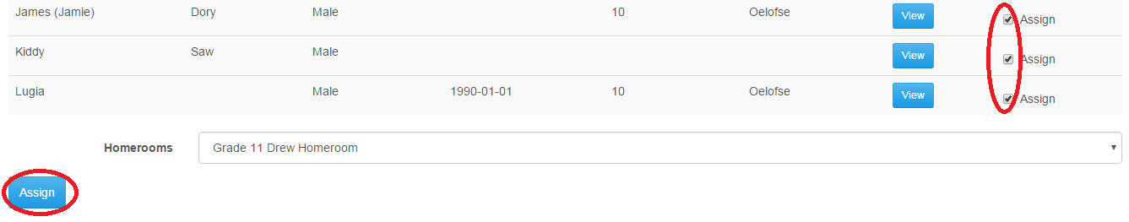

# **23.) Managing your students(Creating and assigning accounts[Preferred Method])**

Assigning accounts to your students is very vital as your billing will be associated to your students. It is much easier to create and link the account under each student, otherwise you may create the account under the Master data tab, accounts link. Then linking them afterwards, please follow our steps below to create and link accounts.

## **23.1)Step by step guide 🡪 Navigating to the students section**

Please navigate to students under the “Master Data” menu, then to “Students”, as displayed below:



## **23.2)Step by step guide 🡪 Navigating to Browse Students**

Navigate to the “Browse” link shown below.



## **23.3)Step by step guide 🡪 Selecting the Student to view**

Click on the “View” button as shown below on the student in which you would like to link and add a parent to.



## **23.4)Step by step guide 🡪 Navigating to creating an account**

Click on the “Create a new account” button as shown below on the student in which you would like to link and add a parent to.

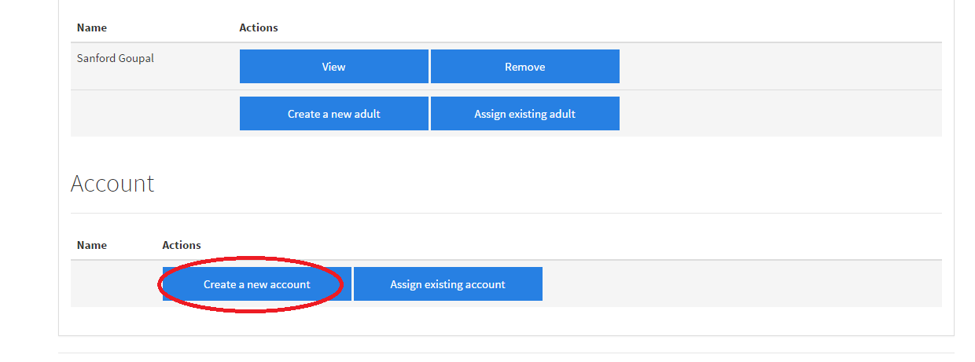

## **23.5)Step by step guide 🡪 Creating an account**

You will be presented with the screen as shown below, please enter the account details as well as the internal account name, which is known as the “Pastel name” for the account. Once complete, click on the “Create” button as shown below.

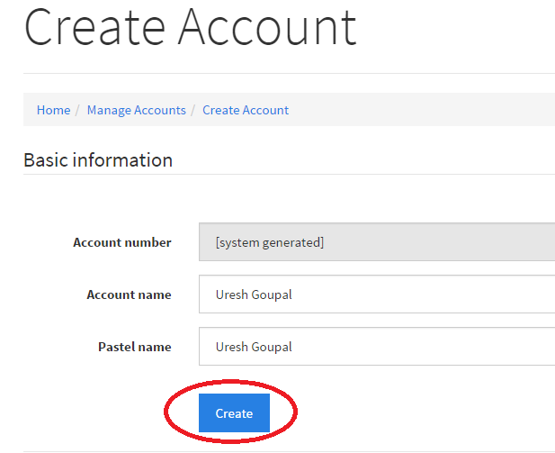

# **24.) Manage your accounts(Viewing and updating your account)**

Once students have been linked to your accounts, you may view all your all your accounts as shown below.

## **24.1)Step by step guide 🡪 Navigating to the Accounts section**

Please navigate to Accounts under the “Financial” menu, then to “Accounts”, as displayed below:

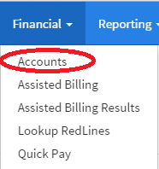

## **24.2)Step by step guide 🡪 Viewing and selecting an account**

All your accounts will be shown below, click on the “edit” button on the account you wish to view the information on as shown below.

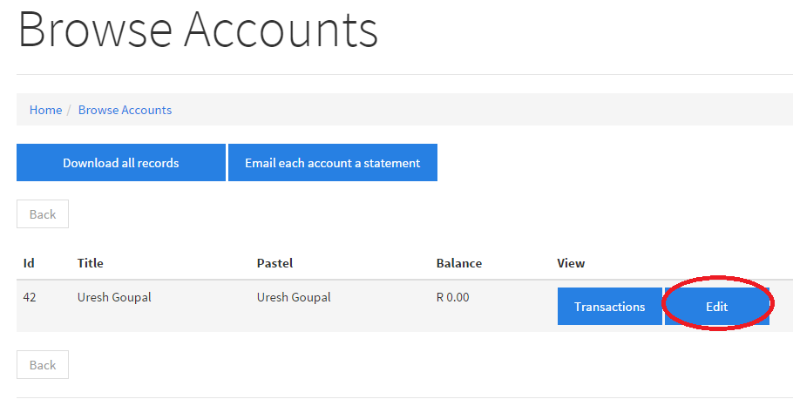

## **24.3)Step by step guide 🡪 Viewing and making changes to your account**

All the details of the account will be shown and can be updated as needed, you will also see the students and parents that are linked with that account.  
Once changes have been made to the account, click on the “Update” button as shown below to update the account details. Please note that on the notes section of the page, internal notes can also be captured for the account.

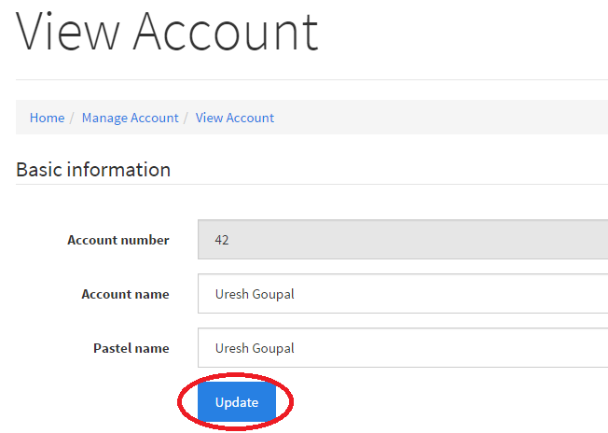

# **25.) Manage your accounts(Making a once off transaction on the account)**

Once off transactions can be made to an account as shown below.

## **25.1)Step by step guide 🡪 Navigating to the Accounts section**

Please navigate to Accounts under the “Financial” menu, then to “Accounts”, as displayed below:



## **25.2)Step by step guide 🡪 Viewing the account to make transactions**

All your accounts will be shown below, click on the “Transaction” button on the account you wish to transact with.

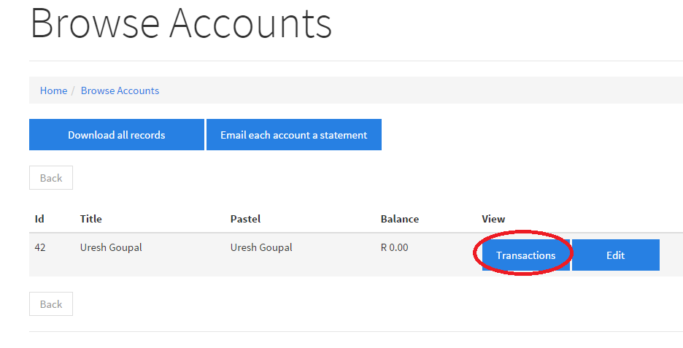

## **25.3)Step by step guide 🡪 Navigating to the Accounts section**

You will see the screen displayed below, please either fill in a debit or credit that will go on the account, the note section will be used for the note that will be displayed on the statement. Once confirmed, click on the “Create” button as shown below. Debit is for parents owing the school, a credit is for parents paying the school.

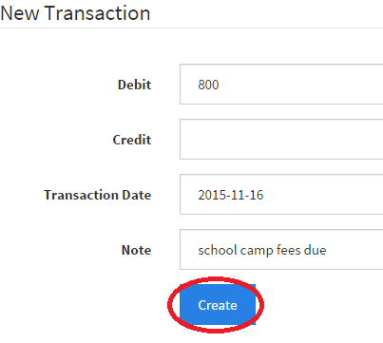

# **26.) Manage your accounts(Using the quick pay feature)**

You may use the quick pay feature as an alternative to step 39. A transaction can be logged against the account at a much faster pace.

## **26.1)Step by step guide 🡪 Navigating to the Quick Pay section**

Please navigate to Quick Pay under the “Financial” menu, then to “Quick Pay”, as displayed below:

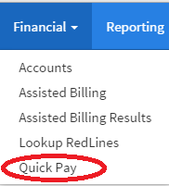

## **26.2)Step by step guide 🡪 Navigating to the account within the Quick Pay section**

Please enter the Student Name, Parent Name or Account Name within the search bar to bring up the accounts that is related to your search query. Please click on the search button as shown below to bring up the search results.

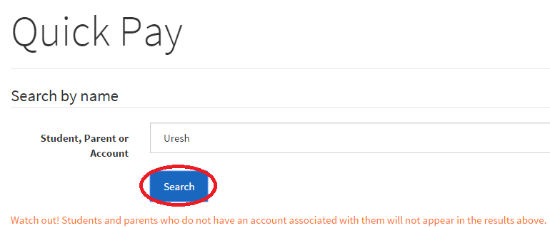

## **26.2)Step by step guide 🡪 Creating a quick transaction**

Please enter the amount, add a minus sign if a parent is paying the school eg) -600, if you would like to bill the account, add a positive value eg)600.  
Add a note associated with the transaction, the date of the transaction as well as select the correct account in which this transaction should be applied to, as shown below. Once completed, click on the “Create” button.

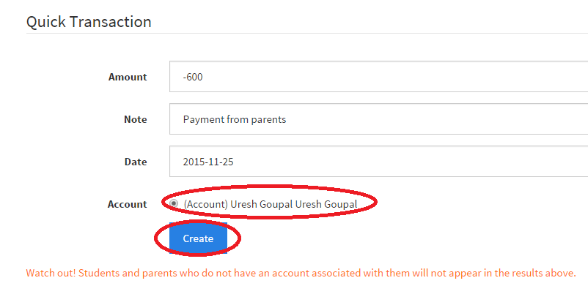

# **27.) Manage your accounts(Billing the whole school, grades or homerooms)**

Assisted billing allows you to bill the entire school with just a single click of a button. You may also choose to bill, entire grades or entire homerooms separately.

## **27.1)Step by step guide 🡪 Navigating to the Assisted Billing Section**

Please navigate to Assisted Billing under the “Financial” menu, then to “Assisted Billing”, as displayed below:

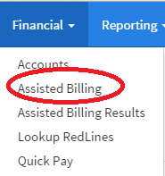

## **27.2)Step by step guide 🡪 Starting with the assisted billing process**

Please take note of the steps below, before you start the assisted billing

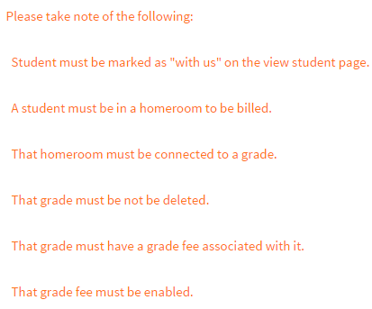

## **27.3)Step by step guide 🡪 Billing selection and submission**

Please select from the choices as shown below, if you would like to bill the entire school, individual grades or individual homerooms. Please also select the date of when the transaction should take place, once completed click on the “Submit” button.

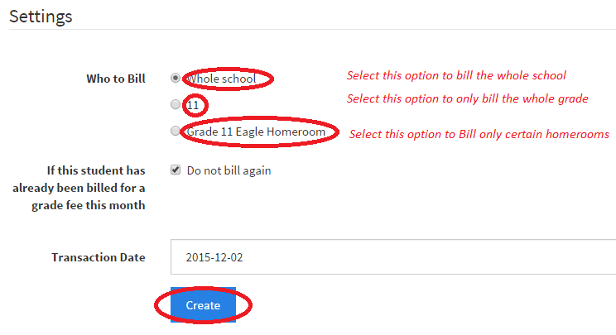

## **27.4)Step by step guide 🡪 Billing Results**

Billing results will be displayed as shown below, on the students that were successfully billed, students that were not billed due to them already being billed. Students who were not billed will also be displayed as shown below:

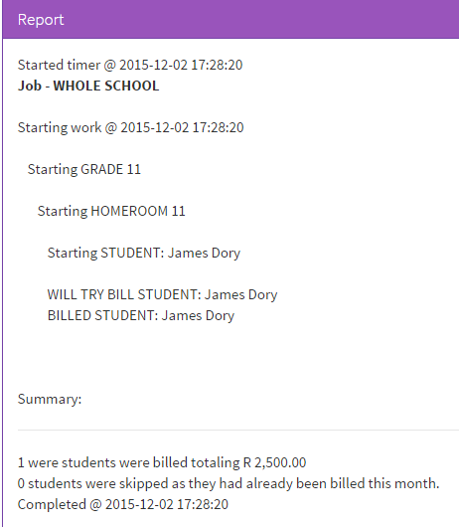

# **28.) Viewing your billing results**

Viewing your billing results can be checked to view which kids have been successfully billed and which have not been billed due to missing information linking to their student profile. Kids will not be billed twice within the same month, if a child has already been billed, the automatic billing will skip and move onto the next child to be billed.

## **28.1)Step by step guide 🡪 Navigating to the Assisted Billing Results Section**

Please navigate to students under the “Financial” menu, then to “Assisted Billing Results”, as displayed below:

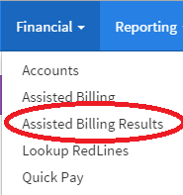

## **28.2)Step by step guide 🡪 Selecting the period in which the Assisted Billing had taken place**

Please select the period in which the Assisted Billing had taken place by clicking on the “View” button as shown below.

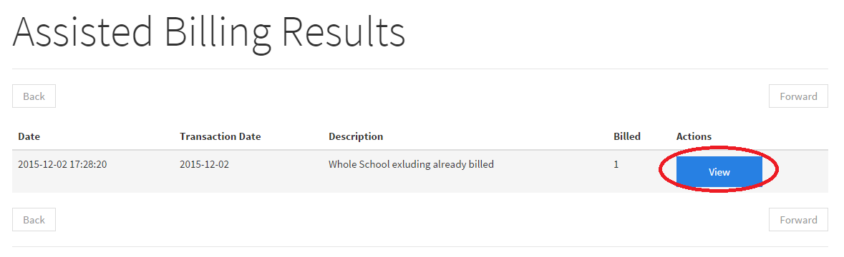

# **29.) Manage your accounts(Viewing transactions within an account)**

You may view all the transactions that have been associated with the account displayed below.

## **29.1)Step by step guide 🡪 Navigating to the Accounts section**

Please navigate to students under the “Financial” menu, then to “Accounts”, as displayed below:



## **29.2)Step by step guide 🡪 Selecting the account to view**

All your accounts will be shown below, click on the “Transaction” button on the account you wish to transact with.



## **29.3)Step by step guide 🡪 Selecting the account to view**

Your transactions will be displayed at the bottom of the screen as shown below.

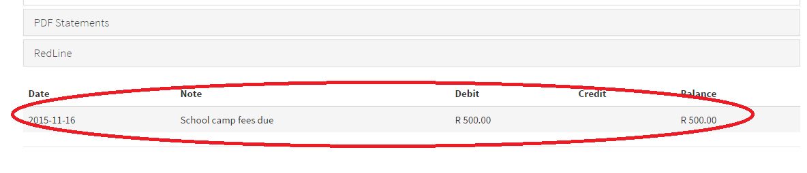

# **30.) Manage your accounts(Viewing statements of a single account)**

To view statements of a single account, please see below. Please note that the students details have to be filled in, in order to reflect on the statement.

## **30.1)Step by step guide 🡪 Navigating to the Accounts section**

Please navigate to Accounts under the “Financial” menu, then to “Accounts”, as displayed below:



## **30.2)Step by step guide 🡪 Selecting the account to view**

All your accounts will be shown below, click on the “Transaction” button on the account you wish to transact with.



## **30.3)Step by step guide 🡪 Downloading the PDF Statement of an account.**

Please click on the “PDF’s” tab as shown below, you may choose to download the statements, either per month, per year, or you can select “all” to download all the transactions associated to that account.

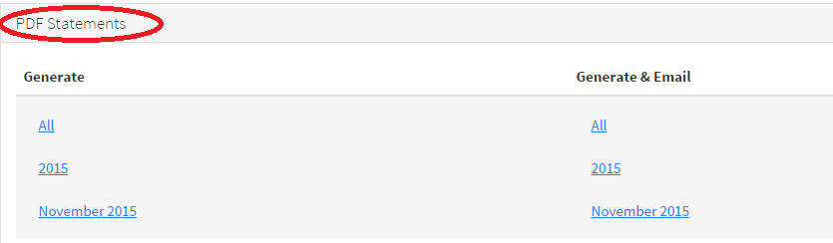

# **31.) Manage your accounts(Downloading all accounts in a single PDF file)**

Downloading all accounts to a single PDF file can be useful, instead of going into each account and printing them. All accounts will be displayed in 1 file and ready to be printed.

## **31.1)Step by step guide 🡪 Navigating to the Accounts section**

Please navigate to Accounts under the “Financial” menu, then to “Accounts”, as displayed below:



## **31.2)Step by step guide 🡪 Download all accounts in a single pdf**

All your accounts will be displayed below, to download all accounts, click on the “Download All Records” button to download all the accounts into 1 pdf file.

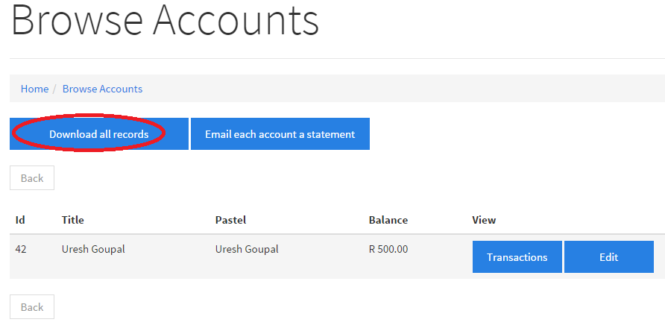

# **32.) Manage your accounts(Setting up red lines on an account)**

Redlining an account will give educators the opportunity to work as a community to rule out the accounts that are considered as “Bad Payment Accounts”. Please note that the Redline feature will be monitored on our side. Please note that Redlining an account should only be used as the last resort when it comes to the parents late payment of school fees. The RedLine lookup can be used to lookup parent’s ID numbers to see if it has been RedLined by other schools and to notify the school of the risk that it is taking by taking in particular parents. ID numbers that are involved with Redlining are hashed in the database, which means that the ID numbers are encrypted and cannot be seen by anyone.

## **32.1)Step by step guide 🡪 Navigating to the Accounts section**

Please navigate to students under the “Financial” menu, then to “Accounts”, as displayed below:



## **32.2)Step by step guide 🡪 Selecting the account to view**

All your accounts will be shown below, click on the “Transaction” button on the account you wish to transact with.



## **32.3)Step by step guide 🡪 Red Lining an account**

Click on the Redline tab, under the account you wish to redline. Click on the   
“RedLine Account and Associated” button as displayed below.

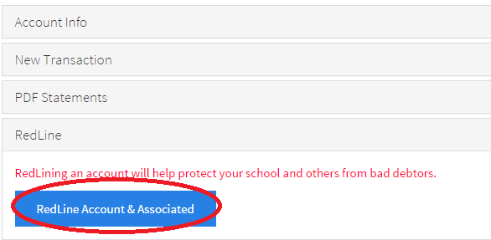

## **32.4)Step by step guide 🡪 Verifying to Redline the account**

You will be displayed with the details of the ID numbers of the adults associated with that account as displayed below. Once you have confirmed the details, click on the “Save” button as shown below.

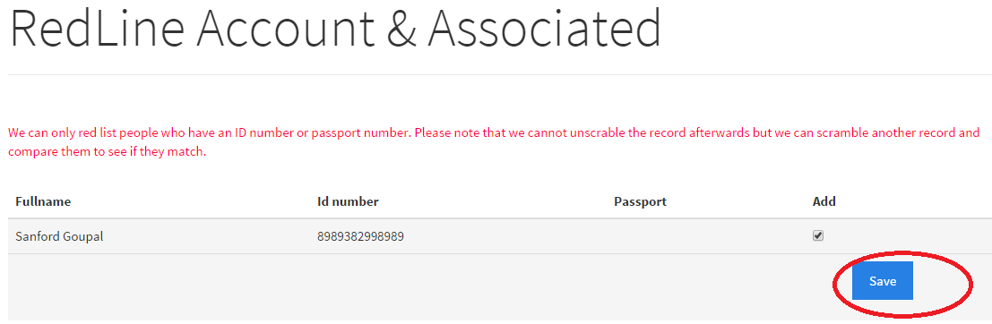

# **33.) Manage your accounts(checking if a parent is RedLined)**

Checking if a parent is RedLined can be used for newer parent’s that would like to join your current school. This will notify the educator if there has been any issues with regards to payments of the parents(This is only if the account has been RedLined already by other schools). Please also note that ID numbers will not be displayed to anyone as they are hashed.

## **33.1)Step by step guide 🡪 Lookup Red Lines section**

Please navigate to Lookup Red Lines under the “Financial” menu, then to “Lookup RedLines”, as displayed below:

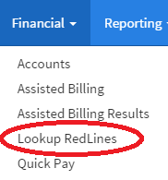

## **33.2)Step by step guide 🡪 Using the Lookup RedLines**

Please enter either the ID number or the passport number of the parent/parents who you would like to lookup as shown below. Once the ID number/passport number has been entered, click on the search button as shown below:

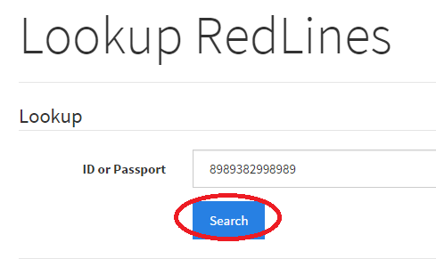

## **33.3)Step by step guide 🡪 RedLine Results**

The results will be shown below, in which case the result is “The has appears 2 times”. This means that the parent has been RedLined twice as a result of non payment.

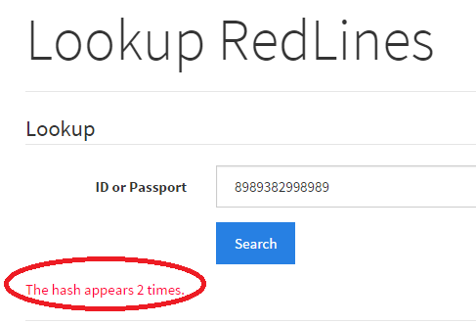

# **34.) Viewing Reports**

There are reports which can be generated on the fly related to the data that is within your school. If there are any additional reports that you would like, please email us at [team@eagleadmin.co.za](mailto:team@eagleadmin.co.za) to send a request for a specific report to be created. Please find a list of reports listed with the descriptions below:

**Account Balances**

Account balances can be generated from a specific date, this will list all accounts which are still active on the system.

**Overdue**

The accounts overdue report will allow you to select accounts which are 42,60 and 90 days overdue.

**Owed vs Received**

The Owed vs Received report will allow you to enter a date in which will show you all the accounts that still owes fees to the school, as well as money received from the accounts. The money that has been received from the accounts can be used as a benchmark against the money that is still owing to the school.

**Most Outstanding**

The most outstanding report will generate a report on the accounts in order from the account who owes the highest amount to the least amount. This will be beneficial to know which account holds the most risk of keeping.

**Best Behaved**

The best behaved account will list the accounts in priority according to how well the account is kept up to date when it comes to the payment of fees.

**Birthday List**

Selecting the birthday list report allows you to generate birthday lists according to students within a specific grade, or students within the whole school. Birthday lists can then be sorted according to the students first name, last name and date of birth. They may also choose to sort them in either descending or ascending order.

**Class List**

Selecting the Class list report allows you to generate class lists according to students within a specific grade, or students within the whole school. Class lists can then be sorted according to the students first name and last name. They may also choose to sort them in either descending or ascending order.

**Emergency List**

The emergency list will list all students with their adults, this is normally printed for emergency purposes. If there is a need to contact a parent linked to the student, this list will provide the parents contact details for a fast response. You may choose to sort emergency lists of all students in 1 file, or you may generate emergency lists according to the students in each grade.

**Students with parents**

The students with parents report will allow you to generate a report that lists all students with their associated parents that are linked to them. You may generate the report as a whole school or make a selection by grade.

## **34.1)Step by step guide 🡪 Navigating to reports**

Please navigate to the reporting tab, then to the report you would like to generate as shown below. A description of each report is listed above.

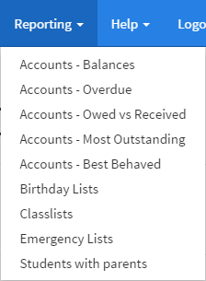

# **35.) Viewing the schools statement of account with Eagle Admin**

Please follow the guide below to access the statement of account to your school, from Eagle Admin. This will display on what is owing to Eagle Admin.

## **35.1)Step by step guide 🡪 Navigating to my account with Eagle Admin**

Please navigate to “My Eagle” then to “My Account” as shown below.  
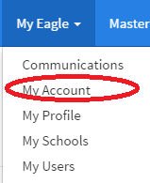

## **35.2)Step by step guide 🡪 Downloading my Statement with Eagle Admin**

Please click on the “Download Statement” button as shown below to download the statement.

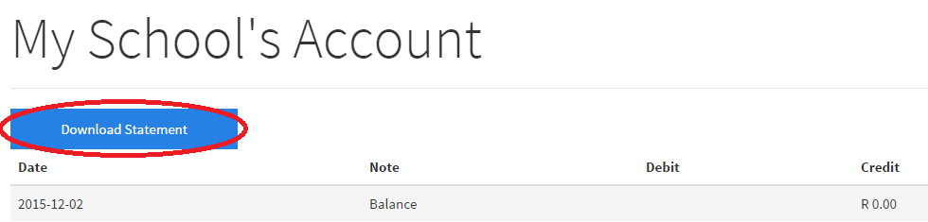

# **36.) Accessing the help feature**

The help feature will display the contact details of the people to call if there are any problems with Eagle Admin. There will also be a FAQ link under the help section to see the most frequently asked questions.

## **36.1)Step by step guide 🡪 Navigating to the help section**

Please navigate to the help tab, then depending on your decision click on either the FAQ button or the Contact Us button to be directed to the relevant pages, as shown below.

